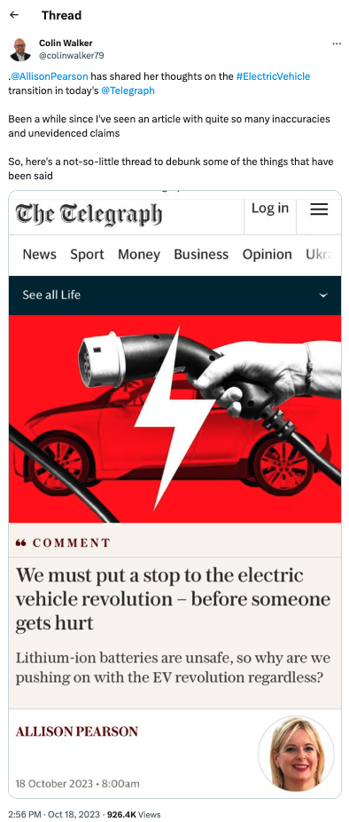
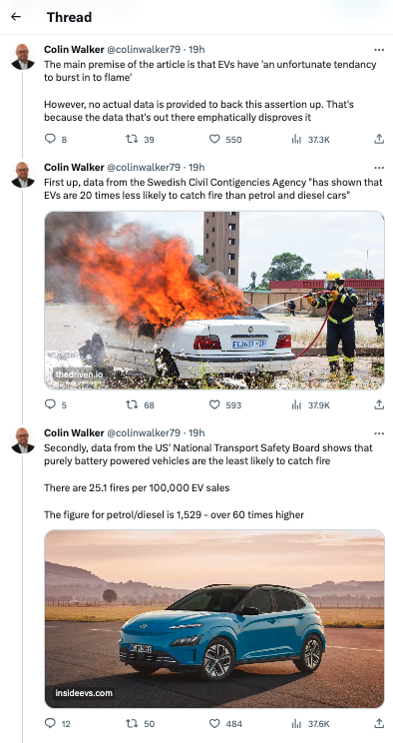
Link: https://thedriven.io/2023/05/16/petrol-and-diesel-cars-20-times-more-likely-to-catch-fire-than-evs/

Link: https://insideevs.com/news/561549/study-evs-smallest-fire-risk/amp/

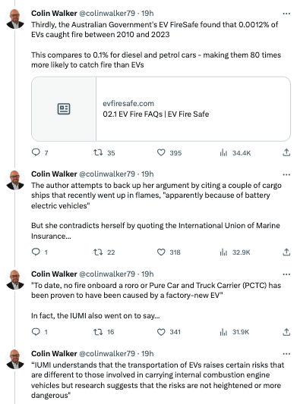
Link: https://www.evfiresafe.com/ev-fire-faqs
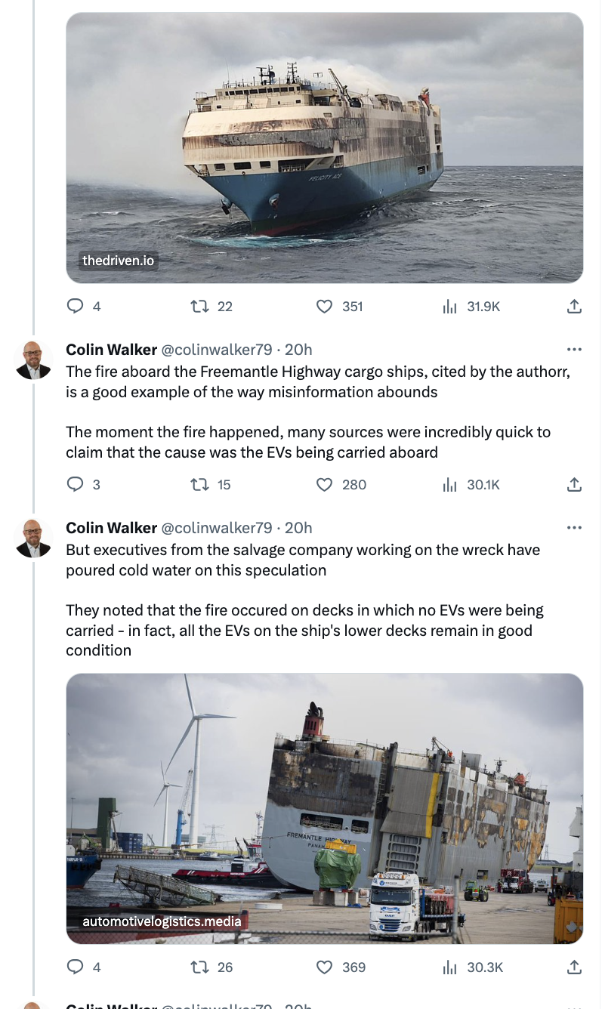
https://thedriven.io/2023/08/14/sorry-ev-haters-big-ship-fire-probably-wasnt-caused-by-electric-cars/
Link: https://www.automotivelogistics.media/electric-vehicles/evs-in-good-condition-after-fremantle-highway-ro-ro-fire/44559.article

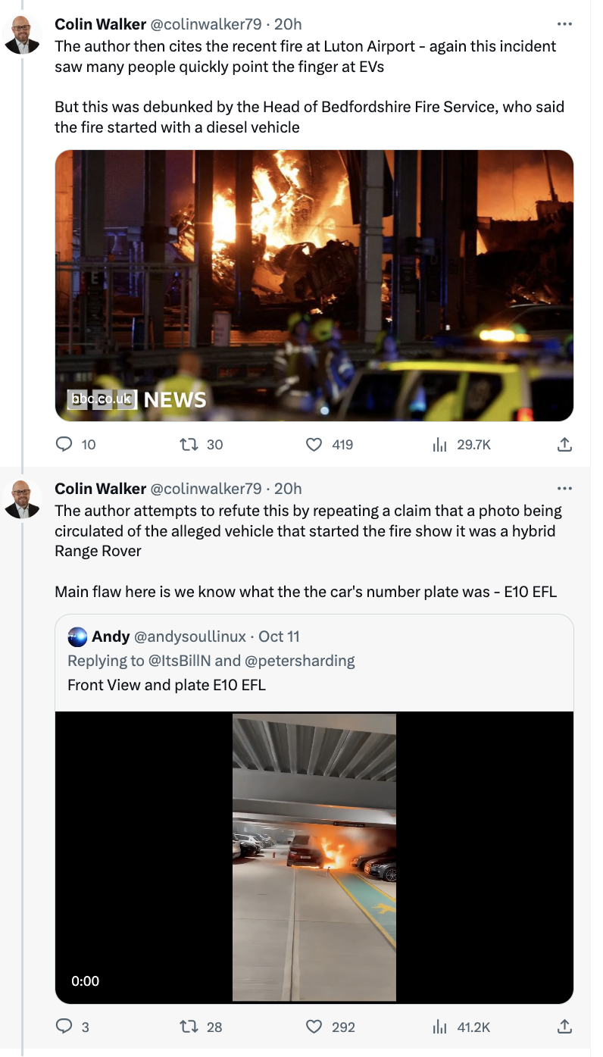
Link: https://www.bbc.co.uk/news/uk-england-beds-bucks-herts-67077996

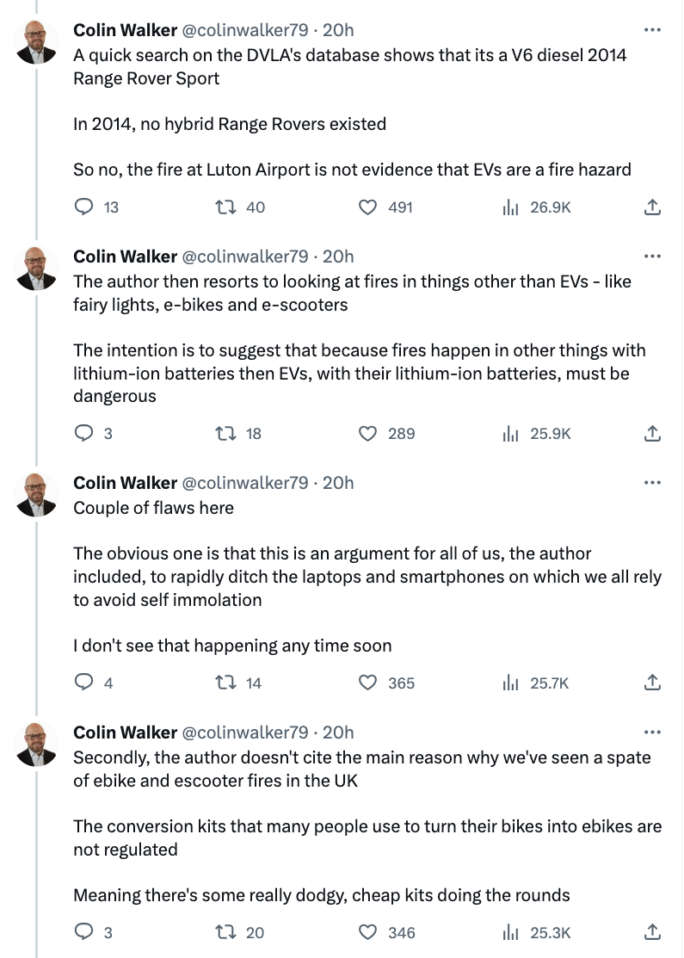
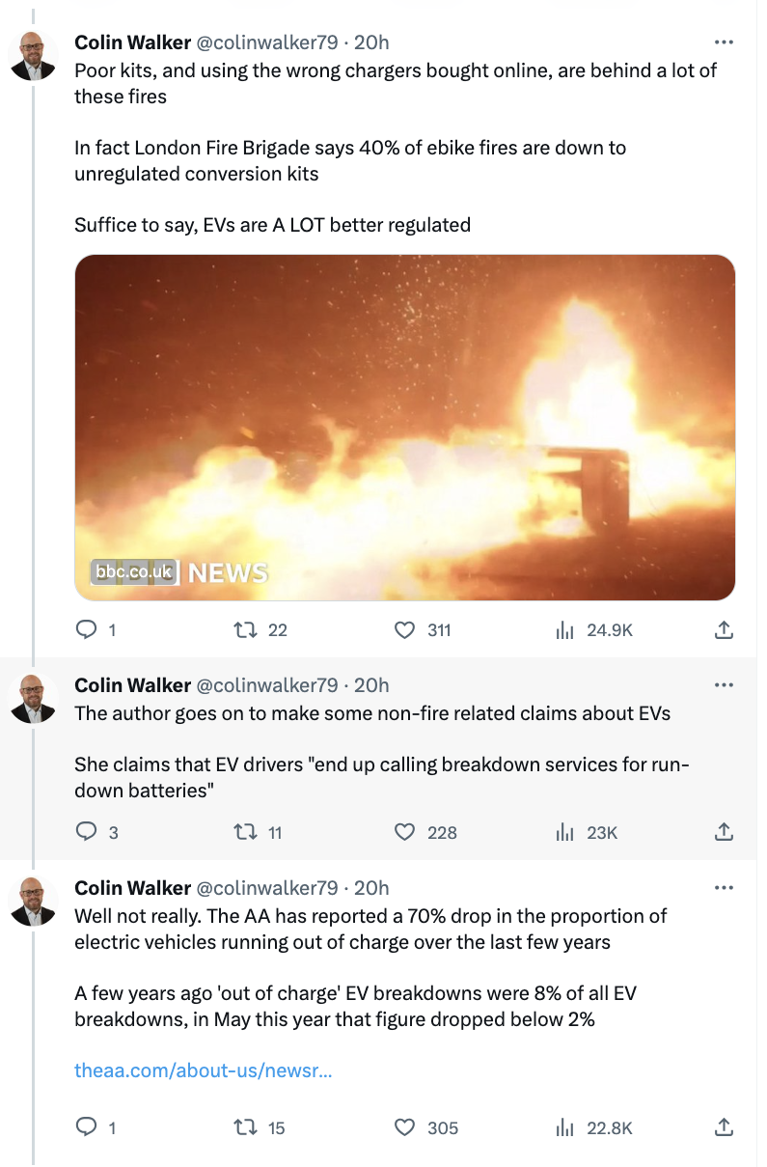
BBC Link: https://www.bbc.co.uk/news/uk-england-london-66497800
The AA Link: https://www.theaa.com/about-us/newsroom/evs-out-of-charge-breakdowns-fall

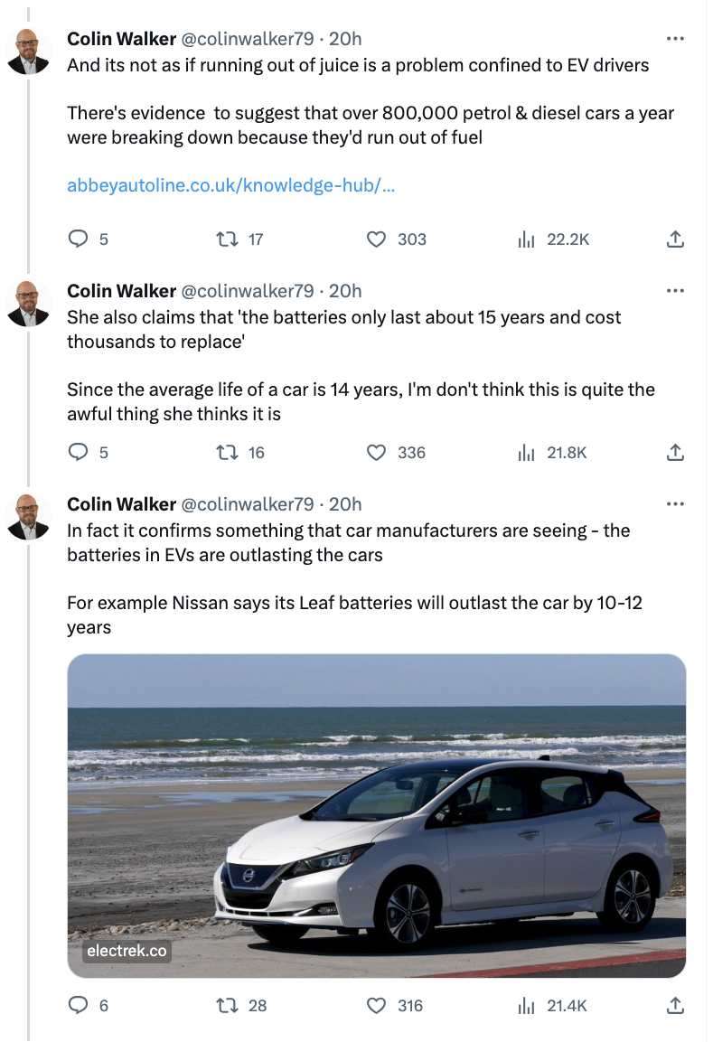
Link: https://www.abbeyautoline.co.uk/knowledge-hub/driving/what-to-do-when-you-run-out-of-fuel/

Link: https://electrek.co/2019/05/24/nissan-leaf-batteries-outlast-car/

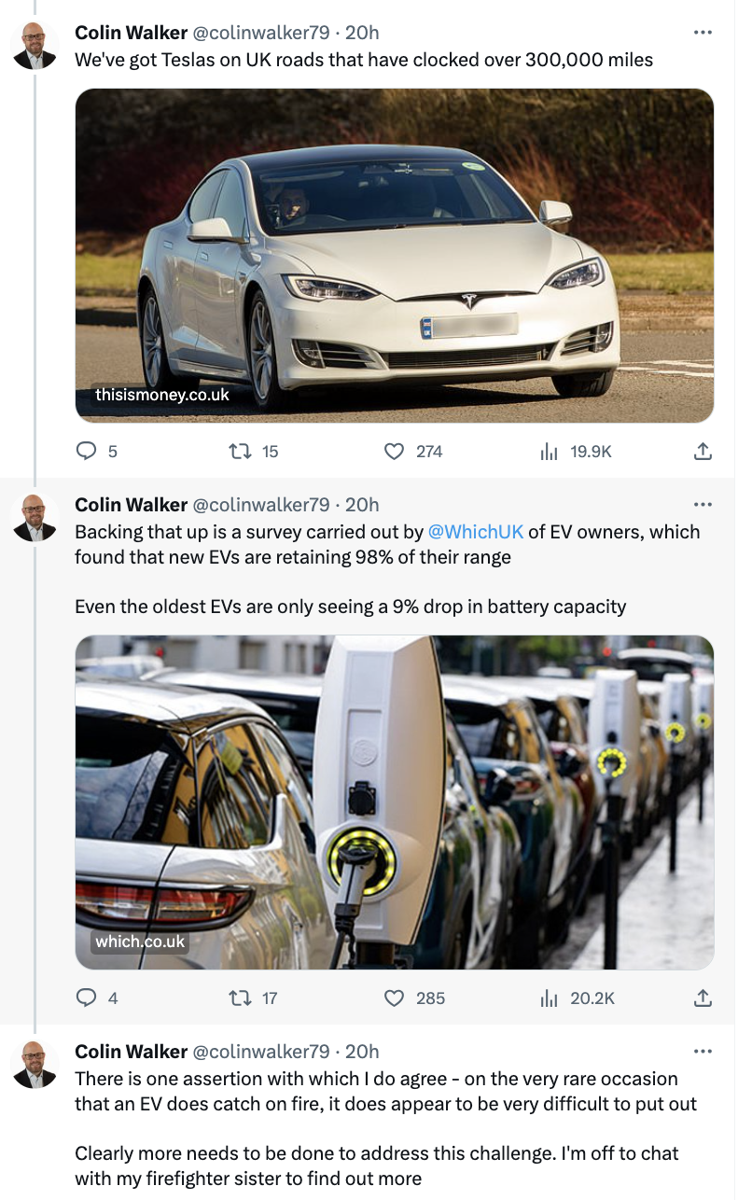
Link: https://www.thisismoney.co.uk/money/electriccars/article-12344229/Teslas-Britain-300-000-miles-batteries.html

Link: https://www.which.co.uk/news/article/the-truth-about-electric-car-battery-degradation-apYqu1y6IYnr

